DevOps Assignment 1

Student Details
Name | Ishan Pravin Patil
Roll No / PRN | 123B1B021
Class | BTech Final Year
Division | A
Subject | DevOps

Objective

The objective of this assignment is to make students practically use Git, GitHub, version control, repository organization, commits, deployment, and basic web hosting by maintaining all previous FSDL assignments in a single public repository and hosting a personal profile website from the same repository.

Repository Description
This repository contains all previous FSDL practical assignments and a hosted personal profile website, maintained under a single public GitHub repository as required by the assignment.

Assignments Included
- a1: Assignment 1 - HTML Tags
- a2: Assignment 2 - Personal Profile Website (hosted via GitHub Pages)
- a3: Assignment 3 - React e-commerce UI (Jucci)
- a4: Assignment 4 - Chart.js data visualization
- A5: Assignment 5 - Node.js/Express/EJS travel packages app
- A6: Assignment 6 - Node.js/Express/EJS property listings app
- A7: Assignment 7 - Full stack e-commerce app (React client + Express server)
Task 1: Create a Single Public Repository for All
Previous FSDL Assignments
Created Repository named FSDL and pushed the assignments in it using
git init
git add .
git commit -m "Initial commit: added FSDL assignments"
git branch -M main
git remote add origin <repository-url>
git push -u origin main

Project Structure
```
FSDL/
README.md
proof.md
screenshots/ (repo-wide proof screenshots)
.github/workflows/ CI/CD (GitHub Pages deployment for a2)
a1/
README.md
table.html
output-screenshots/
a2/
README.md
index.html, about.html, experience.html, projects.html, contact.html
css/, js/, assets/
output-screenshots/
a3/
README.md
src/ (components, context, data)
output-screenshots/
a4/
README.md
src/ (components)
output-screenshots/
A5/
README.md
server.js, data/, views/, public/
output-screenshots/
A6/
README.md
server.js, data/, views/, public/
output-screenshots/
A7/
README.md
client/ (React + Vite frontend)
server/ (Express REST API backend)
output-screenshots/
```

Task 2: Host a Personal Profile Website
Portfolio website is deployed using Github workflow pages and is live on https://ishan1819.github.io/FSDL/

Technologies Used
HTML, CSS, JavaScript, React.js, Node.js, Express.js, EJS, Chart.js, Git, GitHub, GitHub Actions, GitHub Pages

Hosted Personal Profile Website
Live Link: https://ishan1819.github.io/FSDL/

Repository Link
https://github.com/Ishan1819/FSDL

Final Submission
Name | Ishan Pravin Patil
Roll No | 123B1B021
Class | BTech Final Year
Division | A
GitHub Repository Link | https://github.com/Ishan1819/FSDL
Hosted Website Link | https://ishan1819.github.io/FSDL/
Hosting Platform Used | GitHub Pages (deployed via GitHub Actions workflow)
Technology Stack Used | HTML, CSS, JavaScript, React.js, Node.js, Express.js, EJS, Chart.js

Personal Profile Website - Section Checklist (a2)
- Home section - present (index.html hero)
- About me section - present (about.html)
- Education details - present (about.html)
- Skills section - present (about.html / index.html)
- Projects / assignments section - present (projects.html)
- Contact section - present (contact.html)
- GitHub profile link - present (https://github.com/Ishan1819)
- LinkedIn profile link - present (https://www.linkedin.com/in/ishan-patil18/)

Proof / Screenshots Still Required Before Submission
The following items are documentation proof, not code, and must be captured separately (as images or a PROOF.md) before final submission:
- Screenshot of "git --version" output
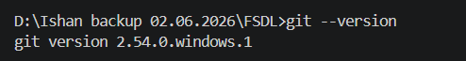

- Screenshot of "git config --global --list" output
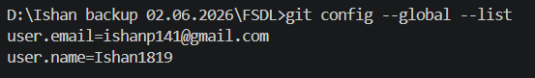

- git usage commands

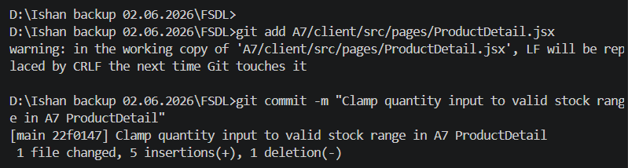

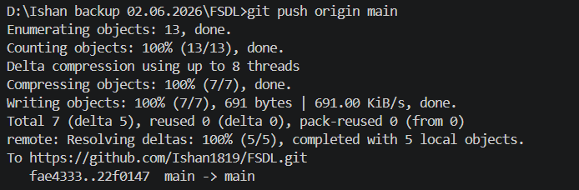

- Screenshot of the local folder structure (a1, a2, a3, a4, A5, A6, A7)
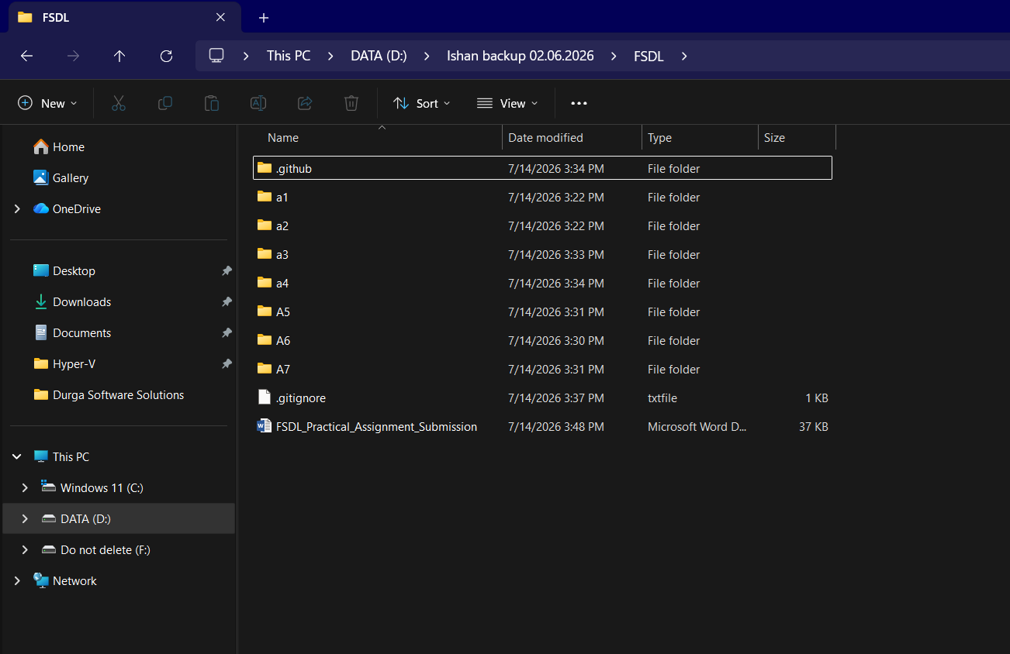

- Screenshot of the public GitHub repository home page
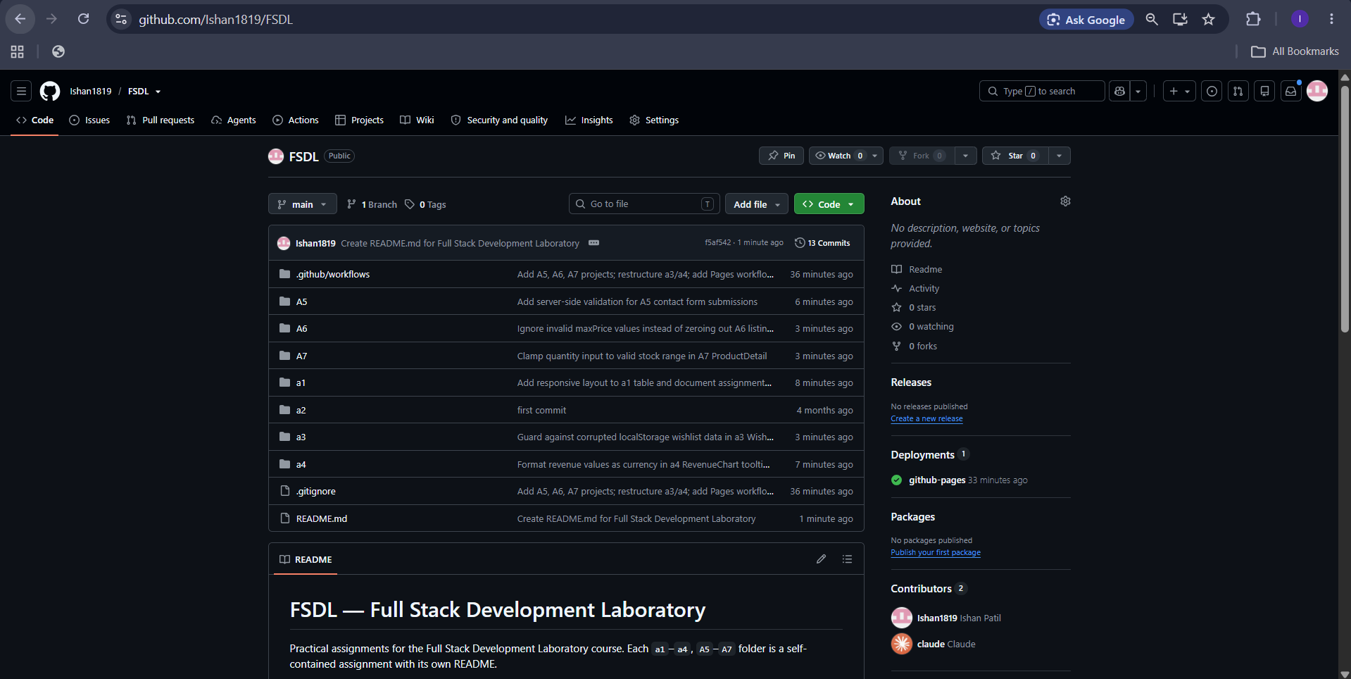

- Screenshot of the commit history (git log --oneline or GitHub commits tab) showing 5+ meaningful commits
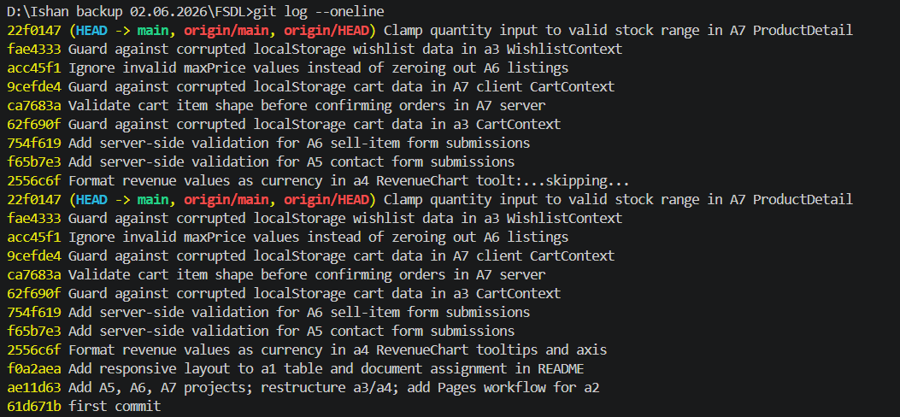

- Screenshot showing all assignment folders inside the repository on GitHub


- Screenshot of GitHub Settings > Pages showing Source = GitHub Actions and the deployed workflow
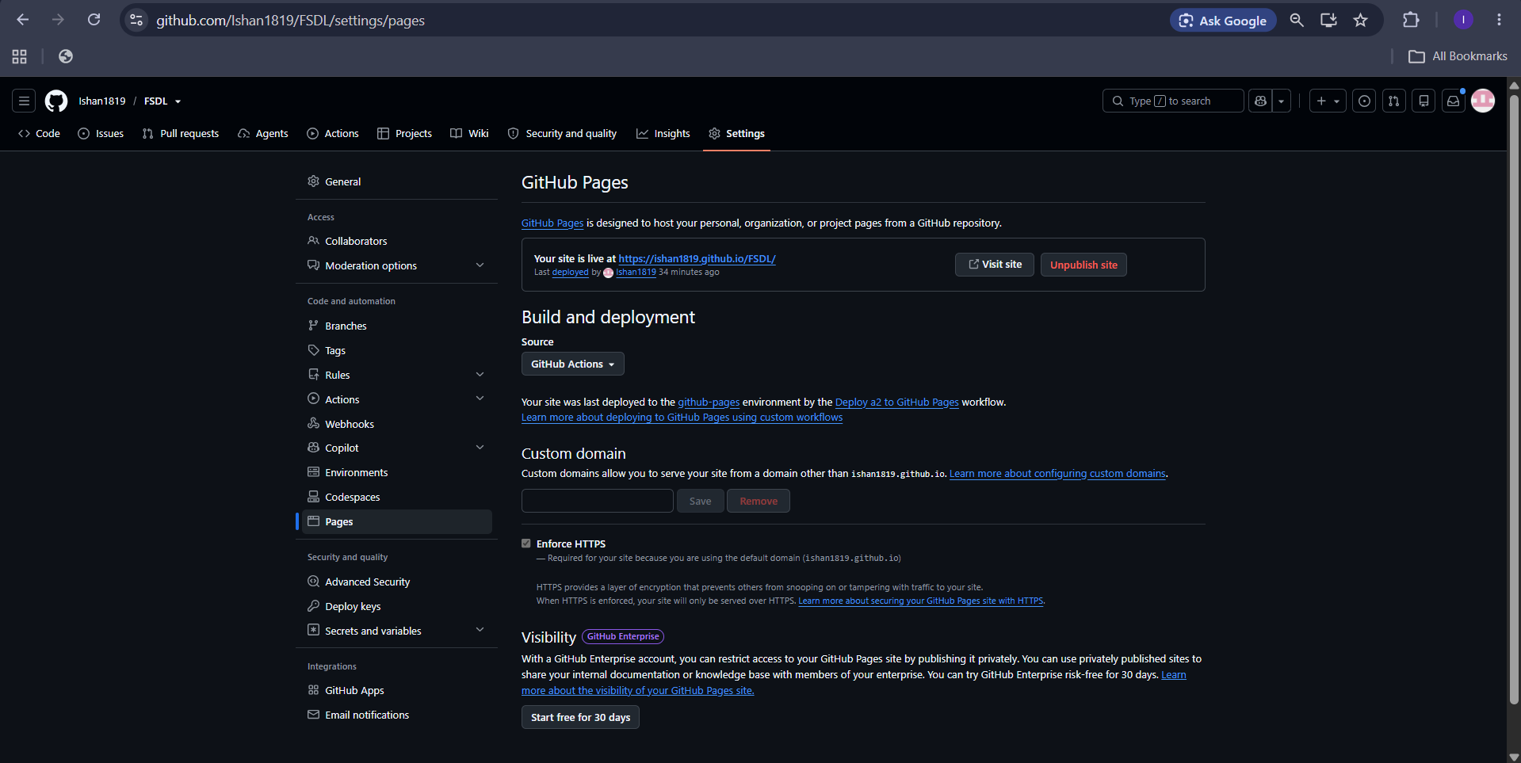

- Screenshot of the live hosted website home page https://ishan1819.github.io/FSDL/
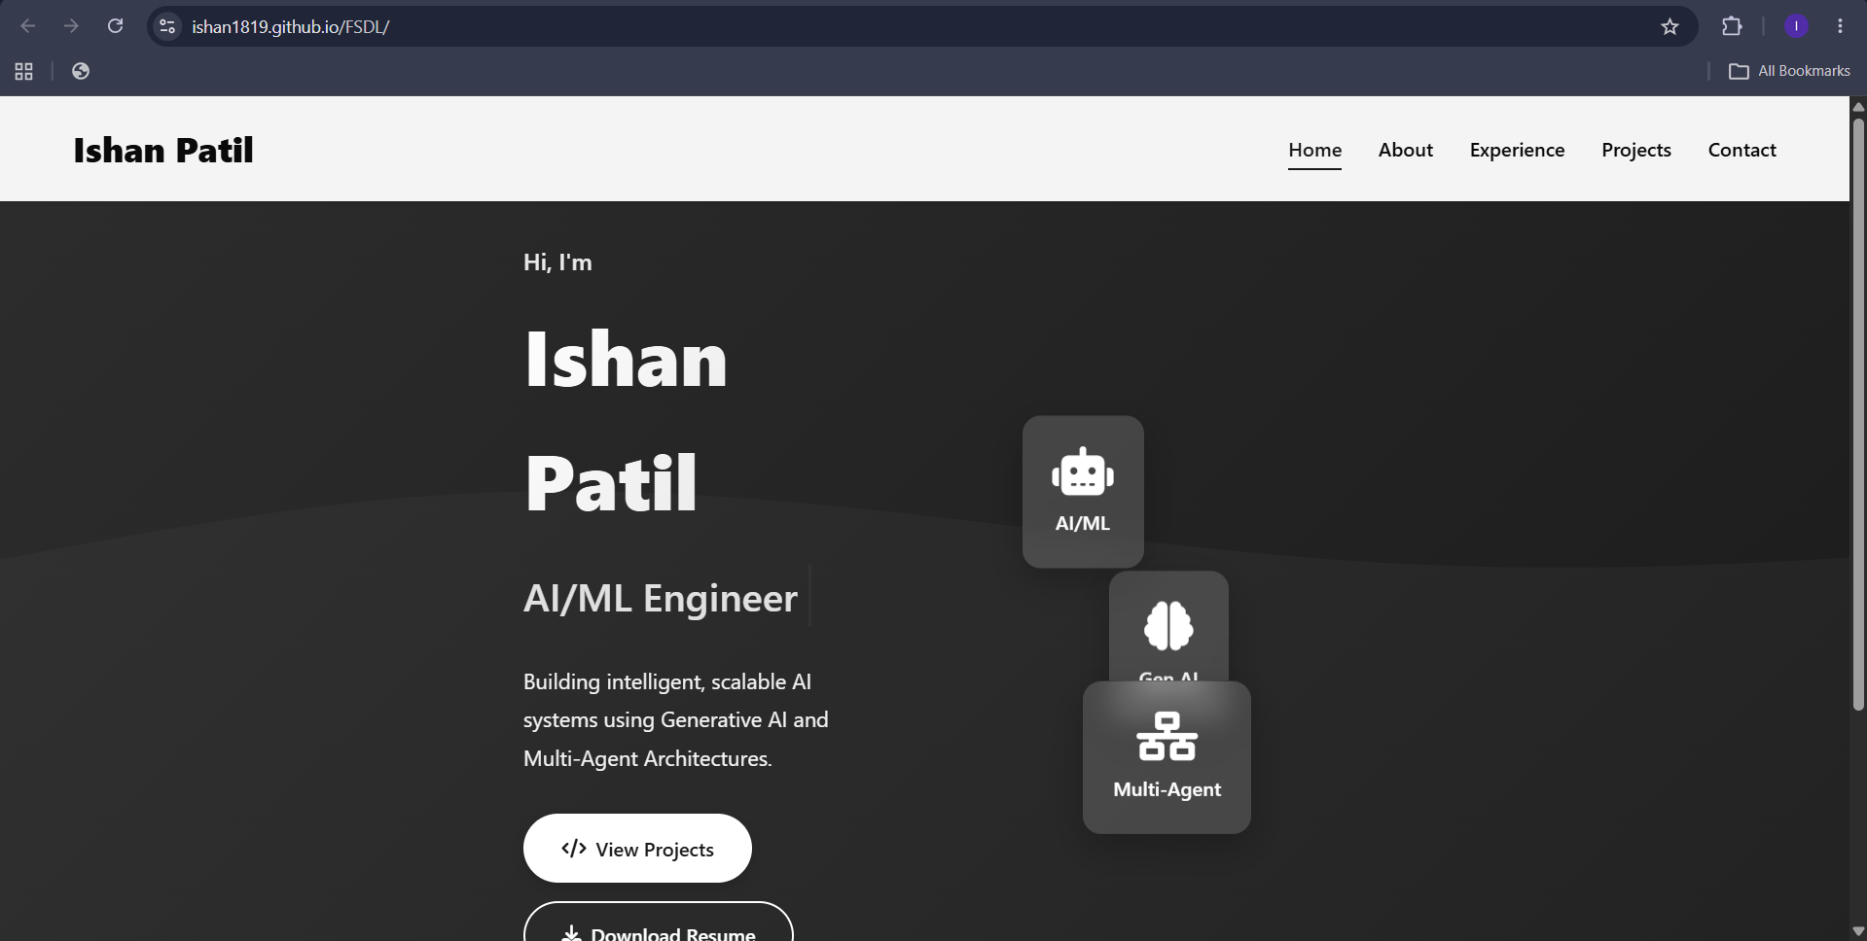

- Screenshot of the GitHub Actions workflow run (green check / successful deployment)
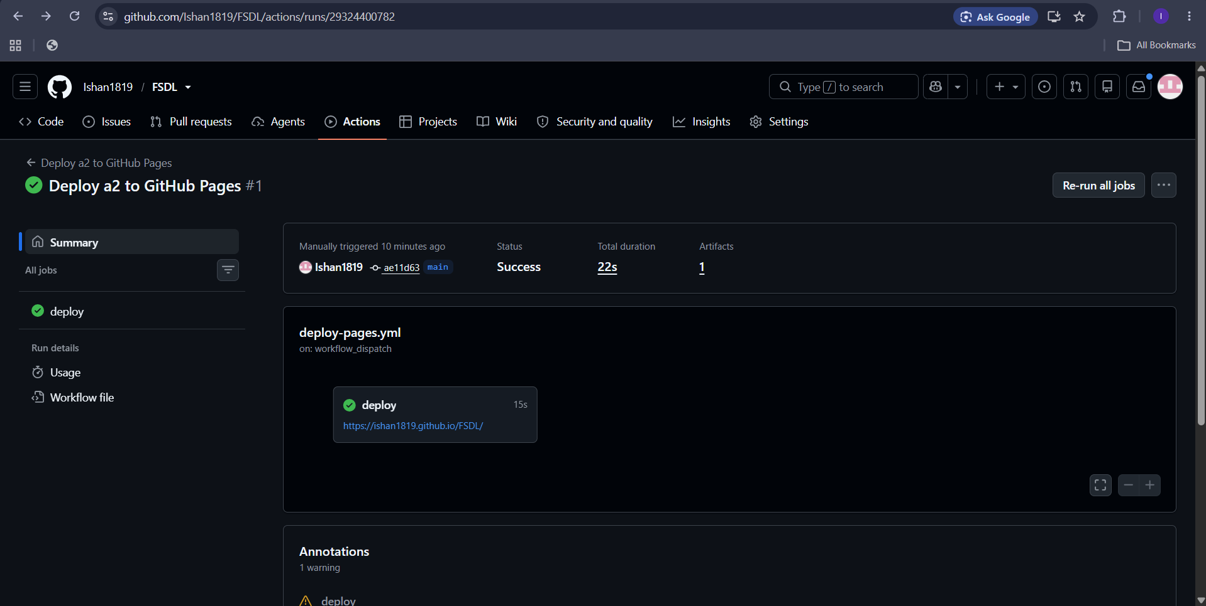

- Screenshot showing a2 files (index.html, css/, js/) inside the repository
